#### Chilkat Lake Sockeye Salmon

Chilkat Lake, located approximately 44 river km upstream from the city of Haines, supports one of the largest runs of sockeye salmon in Southeast Alaska. Chilkat Lake sockeye salmon are primarily harvested in the District 15 commercial drift gillnet fishery in northern Lynn Canal. Smaller but unknown portions of the Chilkat run are harvested in the commercial purse seine fisheries that target pink salmon in Icy and northern Chatham straits (Ingledue 1989; Gilk-Baumer et al. 2015) and in subsistence fisheries in Chilkat Inlet and in the Chilkat River. As noted above, scale pattern analysis has been used to apportion District 15 commercial harvests of sockeye salmon bound for Chilkat Lake and other systems in the area (McPherson 1990). Chilkat Lake sockeye salmon escapements have been estimated through weir counts (1967–1993), weir counts with concurrent mark–recapture estimates (1994 and 1995, 1999–2007), mark–recapture estimates only (1996–1998), and Dual-frequency Identification Sonar (DIDSON) counts with concurrent mark–recapture estimates (2008–2022) (Eggers et al. 2010; Sogge and Bachman 2014; ; Zeiser et al. 2020; Ransbury et al. 2021). Visual weir counts provided minimum estimates of escapement due to flow reversals, turbid water, and frequent lowering of a boat gate in the middle of the weir, all of which potentially allowed fish to pass undetected. Conversely, mark–recapture estimates may be greatly inflated, but may provide an index of escapement (Bednarski et al. 2017). DIDSON counts are also considered minimum estimates of escapement due to undetected passage of small numbers of fish at night during flow reversals; however, confidence in DIDSON counts is much greater than in the visual weir counts.

The current biological escapement goal range of 70,000–150,000 sockeye salmon (Eggers et al. 2008, 2010) was established in 2009. Following a comprehensive review of historical stock assessment data (Bednarski et al. 2017), the escapement goal analysis was last updated in 2018 by Miller and Heinl (2018). With the accumulation of more brood year returns (brood years 1976−2016), the escapement goal was recently reviewed using a similar methodology to Miller and Heinl (2018); an age-structured state-space spawner-recruit model was fit data on abundance, harvest, age composition, and coefficients of variation for calendar years 1976–2022 to examine the effect of autocorrelation on recruits, to account for multiple overlapping methods of escapement enumeration and missing data (age composition was considered unknown in the model for years 1996–1998 when the weir was not operated). DIDSON escapement counts were treated as the ‘true’ counts and the weir counts and mark–recapture estimates of escapement were treated as indices of escapement in the state-space models. Despite the addition of *x* years of data, the resulting parameter estimates were very similar to those estimated Miller and Heinl (2018). As a result, the current biological escapement goal of 70,000–150,000 sockeye salmon, counted with the DIDSON system at the Chilkat Lake weir site (Heinl et al. 2017), remained unchanged.

There has not been consistency in the literature (Subbey et al. 2014), or among agencies, projects, or regions as to whether a log-normal bias correction is applied or is not applied to the productivity parameter before calculating biological benchmarks. Guidelines from Subbey (et al. 2014) suggest that when the target is mean annual recruitment log-normal bias correction should be applied, whereas log-normal bias correction should not be applied when the target is median annual recruitment. This is a separate issue as to whether the posterior mean or posterior median is reported in regard to the log normal bias or to the non-bias corrected productivity parameter.

*The posterior median of escapement leading to maximum sustained yield from the output of the state-space model was 98,370 spawners (95% credibility interval 66,765–223,966 spawners). The probability of achieving 90% of maximum sustained yield (MSY) at the upper and lower bounds of the current escapement goal is estimated to be 62% and 34%, respectively (Appendix Figure B 10), and an average 65% over the entire escapement goal range. Yield would be maximized at escapements near SMSY (near 84% probability of achieving 90% of MSY). These probabilities improve substantially with respect to achieving 80% of MSY. The escapement goal review committee recommended maintaining the current biological escapement goal of 70,000–150,000 fish counted with the DIDSON system at the Chilkat Lake weir site.*

**Table 1.**–Parameter estimates from the state-space model fitted to the Chilkat Lake sockeye salmon data for calendar years 1976–2022. Posterior medians are point estimates; the 2.5th and 97.5th percentiles define 95% credible intervals for the parameters.

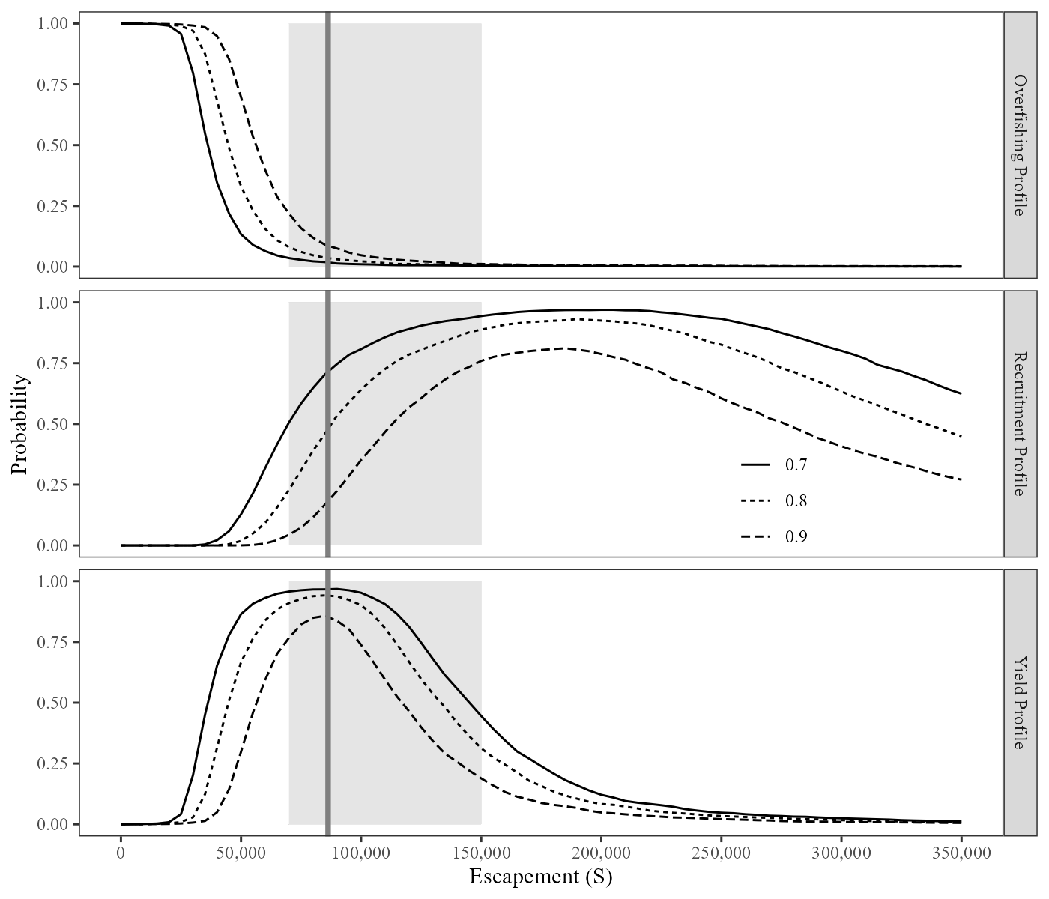

**Figure 1.**–Overfishing profiles (OFPs), optimal recruitment profiles (ORPs), and optimal yield profiles (OYPs) for Chilkat Lake sockeye salmon. OYPs and ORPs show probability that a specified spawning abundance will result in specified fractions (70%, 80%, and 90% line) of maximum sustained yield or maximum recruitment. OFPs show the probability that reducing escapement to a specified spawning abundance will result in less than specified fractions of maximum sustained yield. The shaded region shows the current biological escapement goal range of 70,000 to 150,000 spawners and the solid vertical line is the posterior median of spawning abundance at maximum sustained yield (SMSY) obtained from the state-space model.

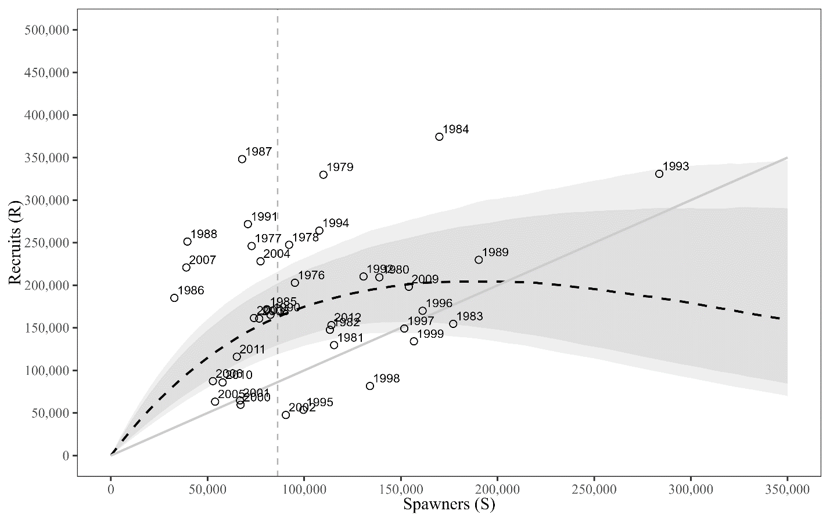

**Figure 2.**– Plausible spawner-recruit relationships for Chilkat Lake sockeye salmon as derived from an age-structured state-space model fitted to abundance, harvest, and age data for brood years 1976–2017. Posterior medians of recruits and spawners are plotted as brood year labels with 95% credible intervals (open circles). The heavy dashed line is the Ricker relationship constructed from ln(α’) and *β* posterior medians with 90% and 95% credibility intervals (shaded areas). Recruits replace spawners on the solid diagonal line. The vertical dotted line is the posterior median of SMSY.

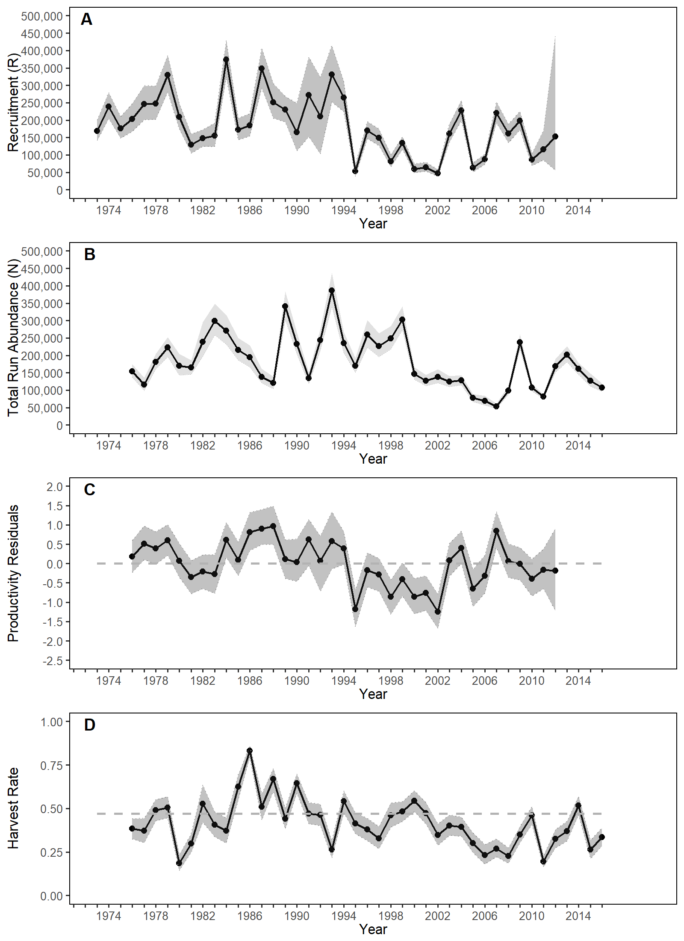

**Figure 3.**– Point estimates (posterior medians; circles) and 95% credible intervals (shaded areas) of escapement, recruitment by brood year, total run abundance, Ricker productivity residuals by brood year, and harvest rates from a state-space model of Chilkat Lake sockeye salmon, 1976–2022. The posterior median of UMSY is plotted as a dashed horizontal reference line in Figure D.

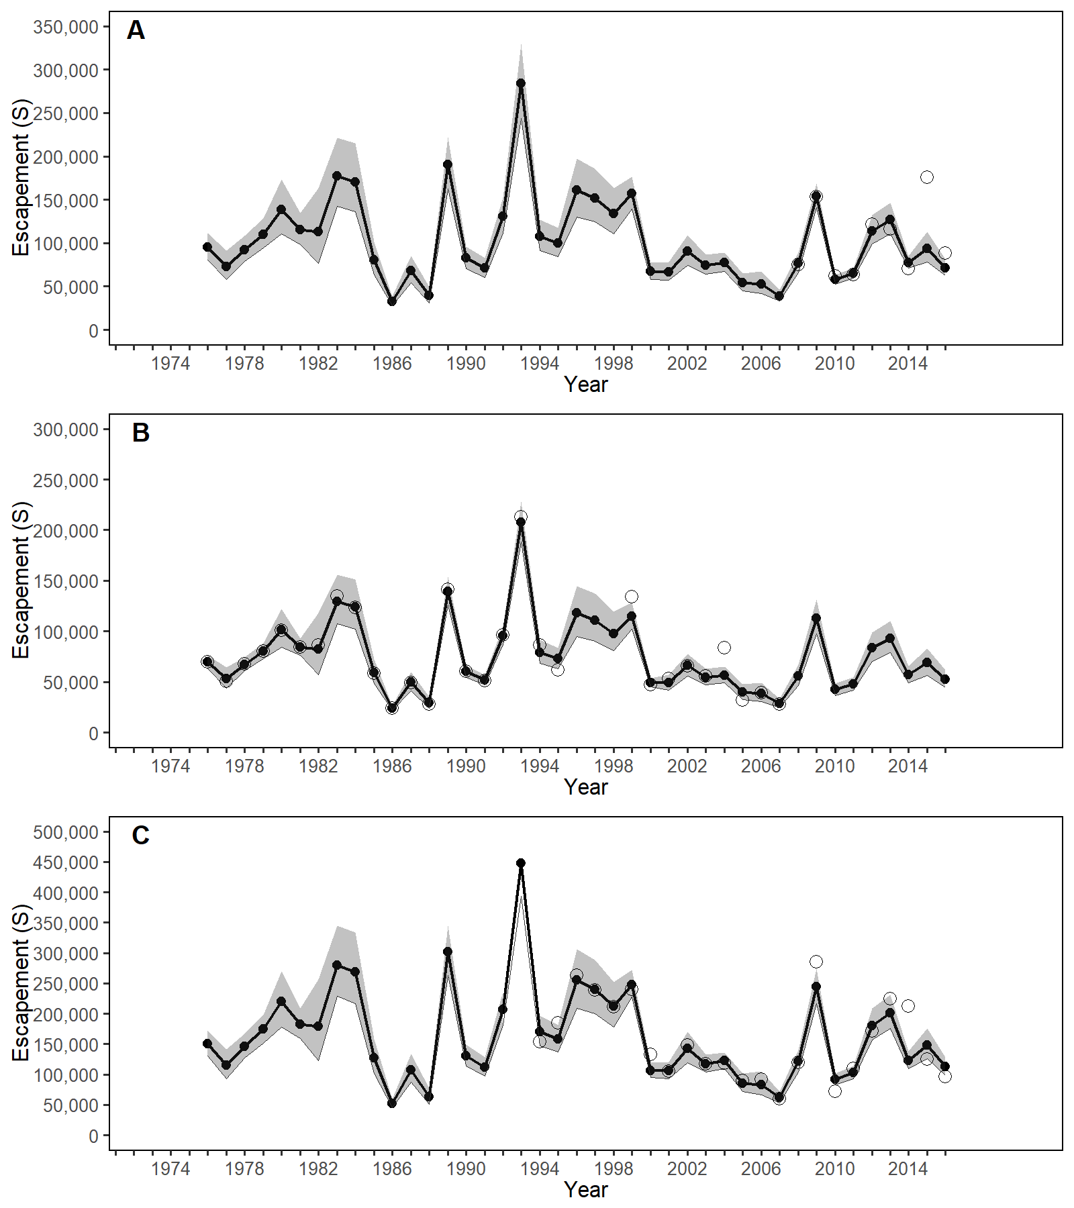

**Figure 4.**– Point estimates (posterior median; solid line) and 95% credible intervals (shaded areas) of escapement (Figure A) and indices of escapement (Figure B and Figure C) from a state-space model of Chilkat Lake sockeye salmon, calendar years 1976–2022. Figure A is the observed (open circles) and modeled (solid line) DIDSON counts, Figure B is the observed (open circles) and modeled (solid line) weir counts, and Figure C is the observed (open circles) and modeled (solid line) mark–recapture estimates.